**Nick Chiodini - 004603962**

**Yousef Jarrar - 005845836**

**HW 1**

**A First Round of Python Questions … To be answered in Lab 1 Based on our study of programs lets_mingle.py, send.py, and catch_me.py, answer the following questions or perform the following tasks in the Python programming language. For some of the question, you may decide to consult online or other sources on Python.**

**1. Write a line of code that assigns value 55 to a variable.**

example = 55

**2. Write the code that prints out all numbers from 1 to 20.**

for i in range(1,11):

print(i)

**3. Write the code that prints out all even numbers between 1 20.**

for i in range(1,21):

If (x % 2 == 0):

print x

**4. Write the code that prints out ten random integers between 1 and 100.**

import random

for x in range(10) :

print random.randint(1,101)

**5. What is the difference between the following two ways of importing modules? import some_module and from some_module import \***

Import some_module → import module imports one object, the module. You can access members of that module via dot notation

Import some_module import * → imports everything that the module exports. It does *not* import the module, so you can't use dot notation.

**6. What is the difference between the following two Python instructions: print “hello” and print “hello”,**

The difference between the 2 pythons instructions is the format being used. When we use **print “hello”** then the shell just prints out whatever is showing, and then starts a new line of instruction. When using **print “hello”,**

We can denote that a separate string can be read and a space is included between the 2 words.

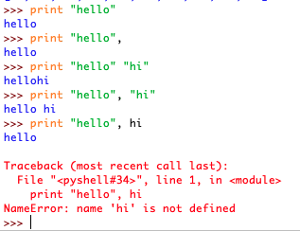

**7. In the declared graphics window object in catch_me.py with win = GraphWin("Catch Me!!", 500, 500) where are the coordinates (0,0) located? (upper left corner, lower left corner, upper right corner, lower right corner).**

The coordinates (0,0) is located in the upper left corner of the grid.

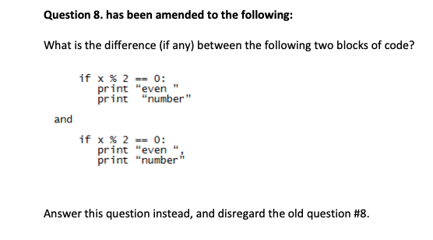

**Answer:**

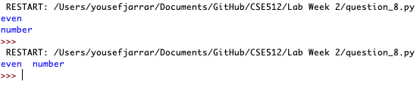

The difference between the 2 blocks of code are the placement of the code. When we run the first block of code, there is a new line that gets placed when the text is printed out. When the second block of code is executed, we notice that the statement is placed on the same line. This is because of the comma insertion used in the block of code.

**9. What is the code to define a class Book with data members for the book title, year of publication and number of pages? What is the instruction that will make variable mybook be assigned the value of a specific Book objects (your choice)?**

*#Question 9*

*#HomeWork - 0*

*#Dr.Voigt - Yousef Jarrar, Nicholas Chiodini*

*class Book:*

*def __init__(self, title, year, page):*

*self.title = title*

*self.year = year*

*self.page = page*

*book = Book("Intro To Artificial Intelligence", 2009, 756)*

*print("Title: ",book.title)*

*print("Year: ",book.year)*

*print("Pages: ",book.page)*

**10. What is the purpose of the line if __name__ == '__main__': in a Python program. The program in catch_me.py features this line, but the program in lets_mingle.py does not include it. What is going on?**

When the python interpreter is reading a source file. It has to define “special” variables first. It can be used as way to import your functions into another python program. Once imported, your module will execute in a different program (completely). In the example in catch_me.py; It is used because it is running our main program from where it was defined. Otherwise known as the main module. It can also sometimes behave as a library. Promotes code resuage.